

Mohammad Ali Jinnah University

Chartered by Government of Sindh - Recognized by HEC

**Assignment 2**

**Name:** Muhamad Fahad

**Id:** FA19-BSSE-0014

**Subject:** [Linear Algebra (Fall 2020)](https://classroom.google.com/u/0/c/MTgxNTU3ODEwMjQw)

**Section:** AM

**Teacher:** Dr. Asmat Ara

**Date:** Saturday, November 7, 2020

1. **Is Linear Algebra easy?**

Linearalgebra far easier than anything of substance in calculus. Linear algebra is mostly about understanding terms and determining which calculation is needed to get the answer.

1. **What do you need to know for linear algebra?**

[For linear algebra you need to know matrix operations or methods like crammers or elimination etc. you need to know basic of mathematics to know the linear algebra.](https://ocw.mit.edu/courses/mathematics/18-06sc-linear-algebra-fall-2011/syllabus/)

1. **What level of math is linear algebra?**

[The level is less than calculus. The starting level is easy be able to compute the determinant of a matrix and understand its relation to volume and inevitability](https://math.stackexchange.com/questions/186782/when-is-linear-algebra-usually-taught)

1. **Is Linear Algebra harder than calculus?**

Yes, many people find linear algebra less intuitive than calculus. There are some concepts that is hard than calculus but because you are going towards the advance concepts it will became harder.

1. **What do you need to know for linear algebra?**

For linear algebra you need to know matrix operations or methods like crammers or elimination etc. you need to know basic of mathematics to know the linear algebra.

1. **What level of math is linear algebra?**

[The level is less than calculus. The starting level is easy be able to compute the determinant of a matrix and understand its relation to volume and inevitability](https://math.stackexchange.com/questions/186782/when-is-linear-algebra-usually-taught)

1. **Is Linear Algebra harder than calculus?**

Yes, many people find linear algebra less intuitive than calculus. There are some concepts that is hard than calculus but because you are going towards the advance concepts it will became harder.

1. **What is the hardest math class?**

Students, learning usually happens best when they can relate it to real life. As math becomes more advanced and challenging, that can be difficult to do. As a result, many students find themselves needing to work harder and practice longer to understand more abstract math concepts.

1. **What is the hardest type of math?**

Calculus is the hardest math subject that most people reach, or almost reach. Only a small percentage of students reach calculus.

1. **What is the point of linear algebra?**

Point of linear algebra is that linear equations are easy to solve

1. **What comes under linear algebra?**

## The linear algebra prerequisite should include the following topics:

* Mathematical operations with matrices (addition, multiplication).
* Matrix inverses and determinants.
* Solving systems of equations with matrices.
* Euclidean vector spaces.
* Eigenvalues and eigenvectors.
* Orthogonal matrices.
* Positive definite matrices.
* Linear transformations.
* Projections.

1. **Which is harder Calc 2 or linear algebra?**

Calc2 is conceptually easy but operationally difficult. Linear Algebra is conceptually difficult but operationally easy.

1. **Do you need trigonometry for linear algebra?**

Linear Algebra you can get away with little or no trigonometry. However it is almost impossible to have a good course in complex analysis without using trigonometry

1. **What is linear algebra vs algebra?**

I think of Algebra as "generalized arithmetic." Algebra is a very general term that includes a wide range of topics. Linear Algebra is the study of vector spaces and linear mappings between those spaces.

1. **Should I learn linear algebra or calculus first?**

[In many university math course sequences,](https://www.quora.com/As-a-computer-science-student-with-no-formal-background-in-mathematics-should-I-study-linear-algebra-or-calculus-first)**[linear algebra](https://www.quora.com/As-a-computer-science-student-with-no-formal-background-in-mathematics-should-I-study-linear-algebra-or-calculus-first)**[is taught after](https://www.quora.com/As-a-computer-science-student-with-no-formal-background-in-mathematics-should-I-study-linear-algebra-or-calculus-first)**[calculus](https://www.quora.com/As-a-computer-science-student-with-no-formal-background-in-mathematics-should-I-study-linear-algebra-or-calculus-first)**[. ... Even if most of the](https://www.quora.com/As-a-computer-science-student-with-no-formal-background-in-mathematics-should-I-study-linear-algebra-or-calculus-first)**[linear algebra](https://www.quora.com/As-a-computer-science-student-with-no-formal-background-in-mathematics-should-I-study-linear-algebra-or-calculus-first)**[curriculum is independent of](https://www.quora.com/As-a-computer-science-student-with-no-formal-background-in-mathematics-should-I-study-linear-algebra-or-calculus-first)**[calculus](https://www.quora.com/As-a-computer-science-student-with-no-formal-background-in-mathematics-should-I-study-linear-algebra-or-calculus-first)**[. That why we first must learn the calculus and then linear algebra.](https://www.quora.com/As-a-computer-science-student-with-no-formal-background-in-mathematics-should-I-study-linear-algebra-or-calculus-first)

1. **Do you use calculus in linear algebra?**

Yes, linear algebra and calculus are very much connected in multivariate calculus. There are also connections between linear algebra and differential equations and most anything else beyond first-year calculus

1. **What is meant by linear algebra?**

Linear algebra is the branch of mathematics concerning linear equations such as: linear maps such as: and their representations in vector spaces and through matrices. Linear algebra is central to almost all areas of mathematics.

Q.1 Find the inverse of the following matrix.

Z=

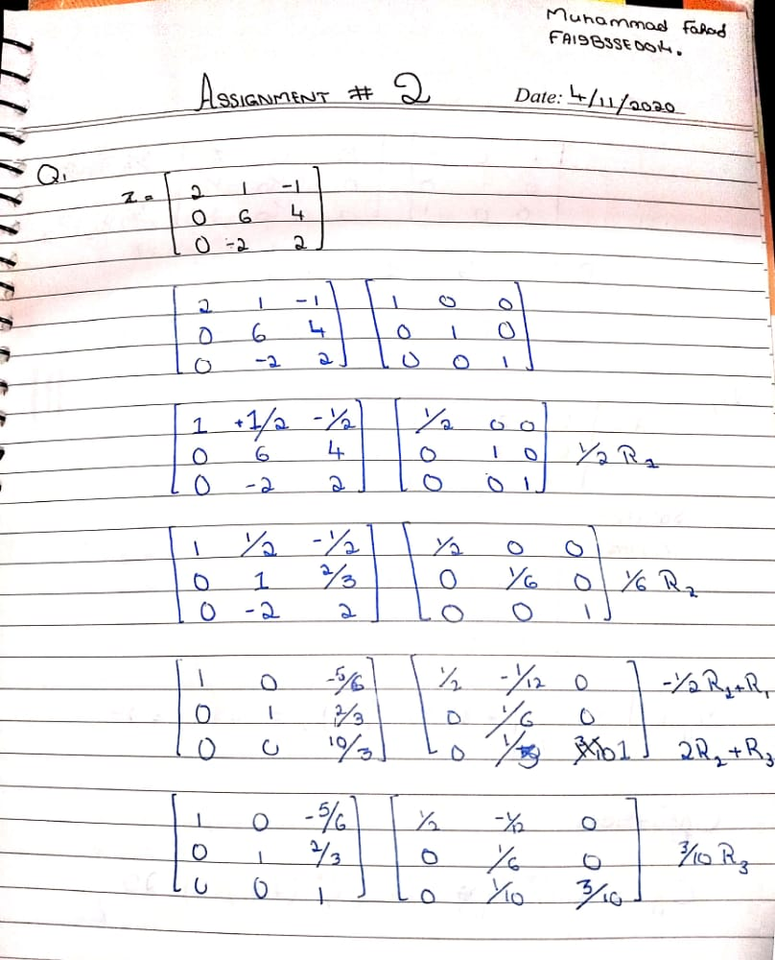

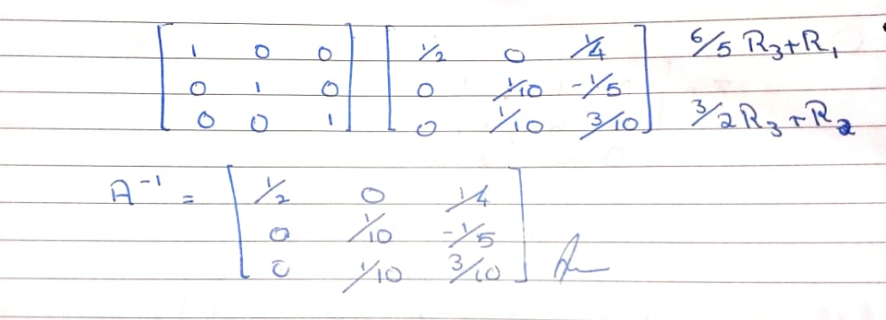

Q.2 Evaluate minor and cofactor of =

A=

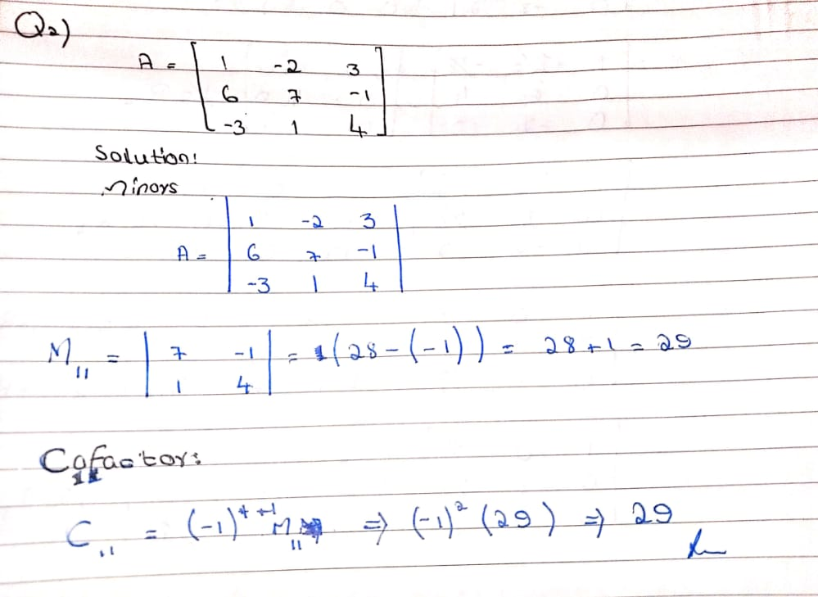

Q.3 Use Cramer’s rule to solve the system of equations.

2x+8y+6z=20

4x+2y-2z=-2

3x-y+z=11

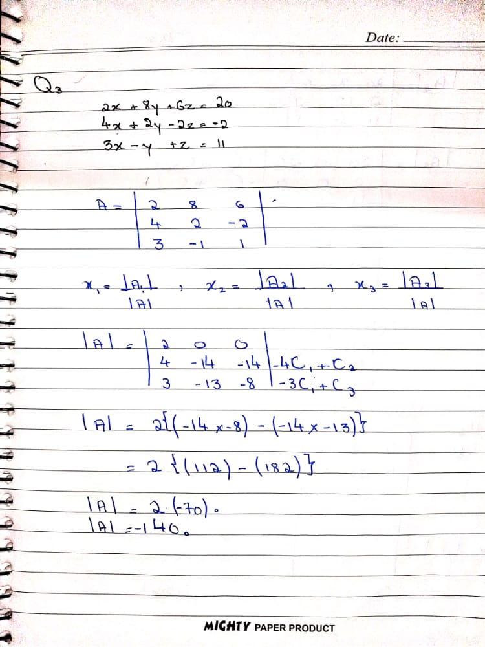

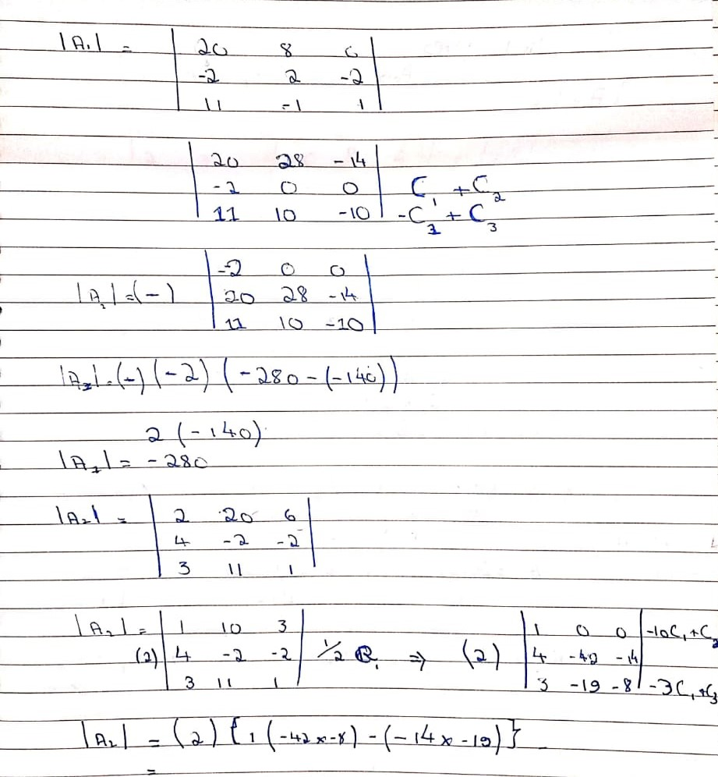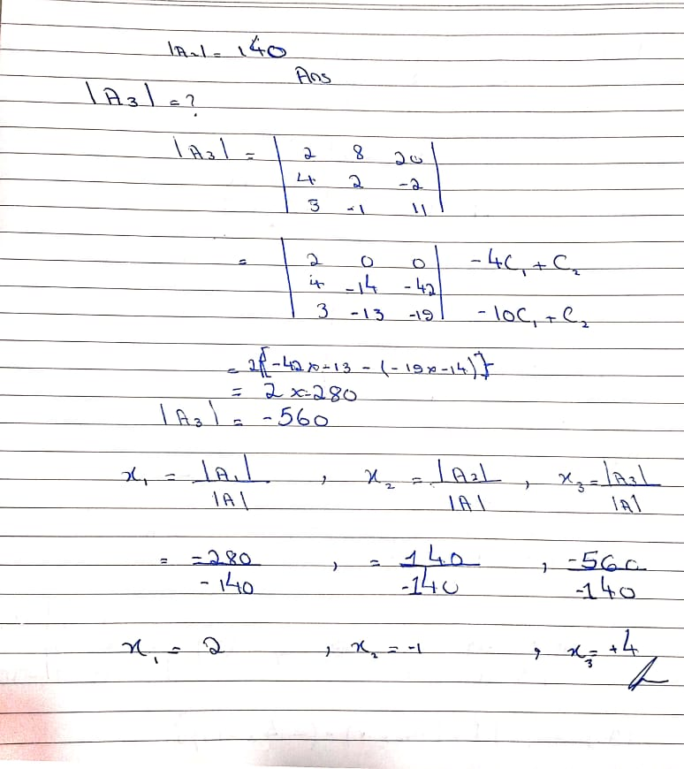

Q4: find the rank and nullity of the matrix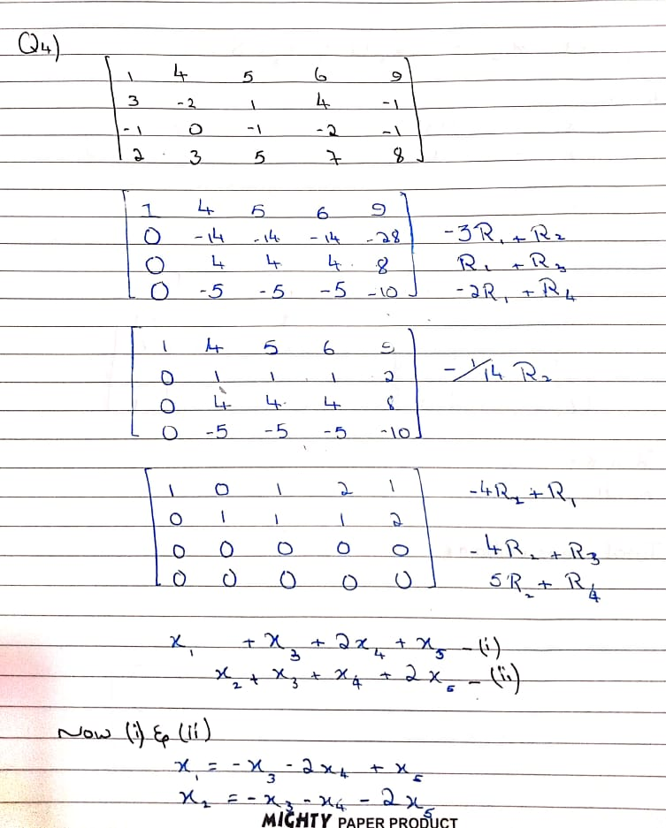

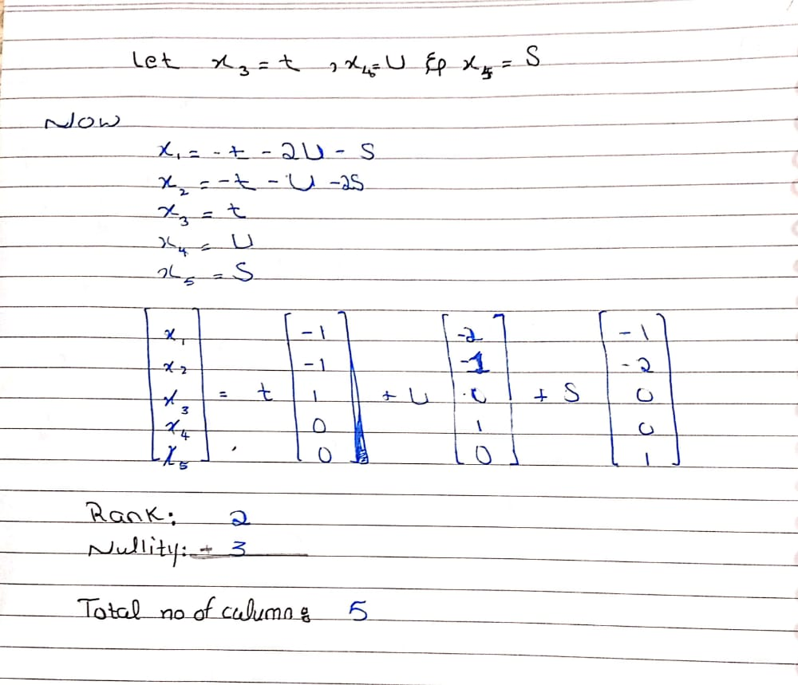

Q5: find the rank and nullity of the matrix 